**0fficial letter sample -appreciation letter**

miss.chitra

vice president of marketing

chitra company

Delhi

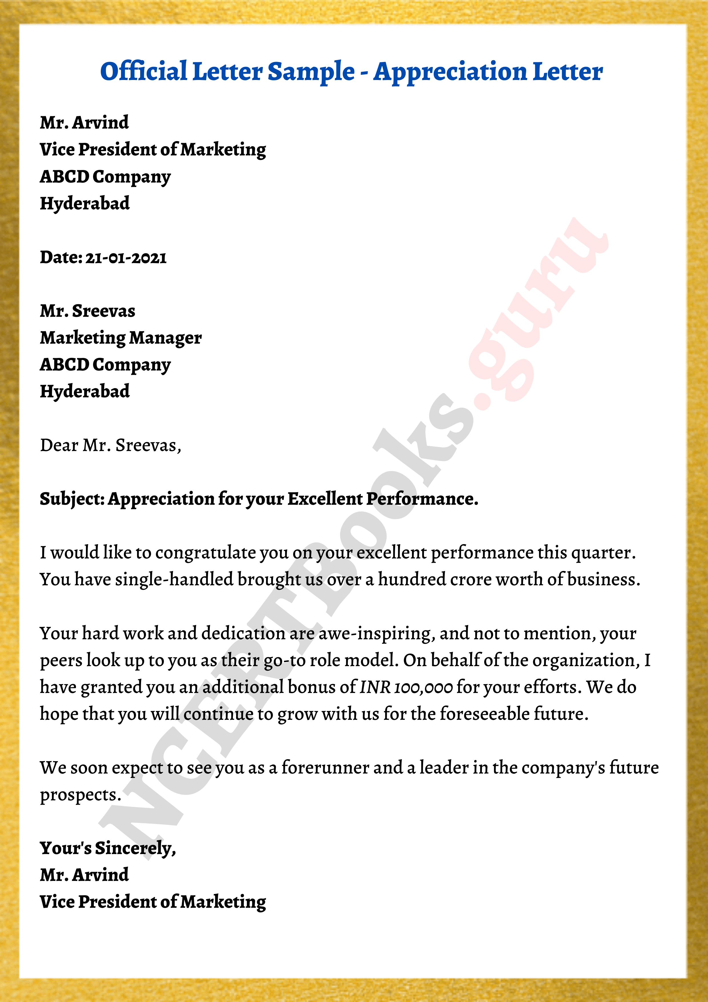

Date :07-05 -2024

Mr.archana

Marketing manager

Vatika company

Delhi

Dear mr.archana

Sub-appreciation for your excellent performance

Video provides a powerful way to help you prove your point. When you click Online Video, you can paste in the embed code 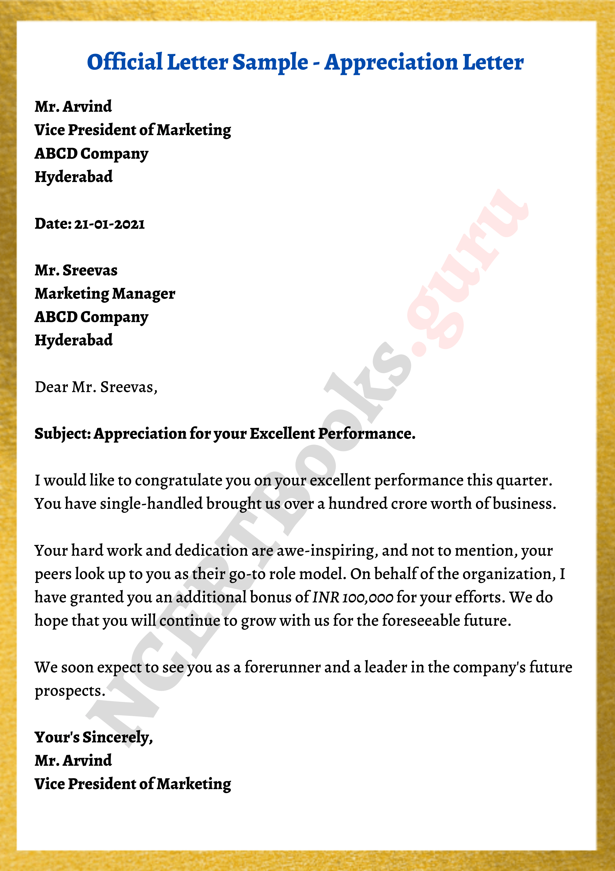for the video you want to add. You can also type a keyword to search online for the video that best fits your document.

To make your document look professionally produced, Word provides header, footer, cover page, and text box designs that complement each other. For example, you can add a matching cover page, header, and sidebar. Click Insert and then choose the elements you want from the different galleries.

Themes and styles also help keep your document coordinated. When you click Design and choose a new Theme, the pictures, charts, and SmartArt graphics change to match your new theme. When you apply styles, your headings change to match the new theme .

Your's sincerely,

Miss. Chitra

Vice president of marketing